**AIM**

To perform the basic router and switch configuration for the given topology and also test the connectivity between all the device via console and vty line.

**COMMANDS USED IN SWITCH**

|  |  |
| --- | --- |
| Commands | Description |
| Switch>enable | Entering enable mode |
| Switch# | Prompt indicates enable mode |
| Switch#conf t | Entering global configuration mode |
| Switch(config)#interface vlan1 | Entering interface configuration mode |
| Switch(config-if)#ip address 192.168.1.1 255.255.255.0 | Enable IP address and Subnet mask |
| Switch(config-if)#no shutdown | Enable the interface |
| Switch(config-if)#exit | Exit in this interface |
| Switch(config)#exit | Exit configuration mode |
| Switch#conf t | Entering global configuration mode |
| Switch(config)#line vty 0 15 | Entering configuration mode for virtual terminal |
| Switch(config-line)#login local | Entering local login |
| Switch(config-line)#user soorya password 1234 | Set user name and password |
| Switch(config)#exit | Then exit configuration mode |
| Switch#conf t | Entering global configuration mode |
| Switch#enable password 6666 | Enable the password |
| Switch(config)#exit | Then exit configuration mode |
| Switch# | Prompt indicates enable mode |

**COMMANDS USED IN ROUTER**

|  |  |
| --- | --- |
| Commands | Description |
| Router>enable | Entering enable mode |
| Router# | Prompt indicates enable mode |
| Router#conf t | Entering global configuration mode |
| Router(config)# interface gig0/0 | Entering interface configuration mode |
| Router(config-if)#ip address 192.168.1.1 255.255.255.0 | Enable IP address and Subnet mask |
| Router(config-if)#no shutdown | Enable the interface |
| Router(config-if)#exit | Exit in this interface |
| Router(config)#exit | Exit configuration mode |
| Router#conf t | Entering global configuration mode |
| Router(config)#line vty 0 4 | Entering configuration mode for virtual terminal |
| Router(config-line)#login local | Entering local login |
| Router(config-line)#user soorya password 1234 | Set user name and password |
| Router(config)#exit | Then exit configuration mode |
| Router#conf t | Entering global configuration mode |
| Router#enable password 2222 | Enable the password |
| Router(config)#exit | Then exit configuration mode |
| Router# | Prompt indicates enable mode |

**PROCEDURE**

1. Configure IP Addressing on the Host PCs.
2. Configure the switches
3. Configure Routers Interfaces.
4. Test and Verify the Configurations.
5. Test and Verify the Telnet.

**TOPOLOGY DIAGRAM**

TOPOLOGY DIAGRAM OF ROUTER AND SWITCH

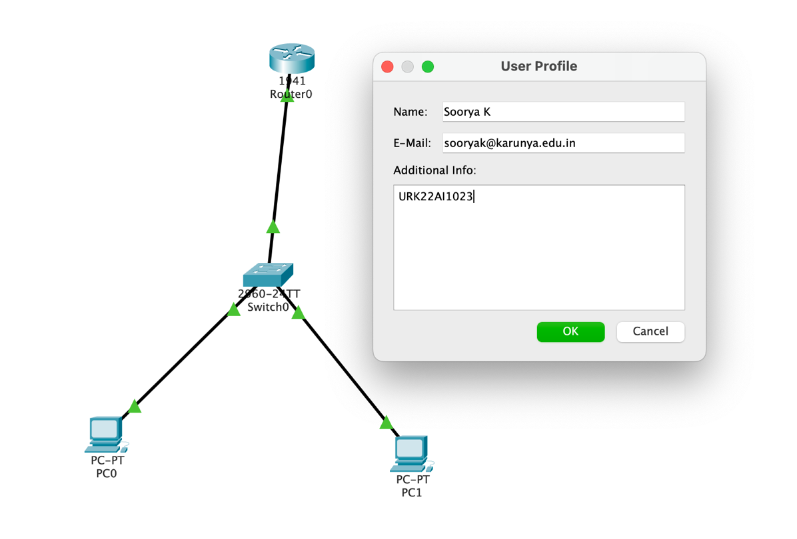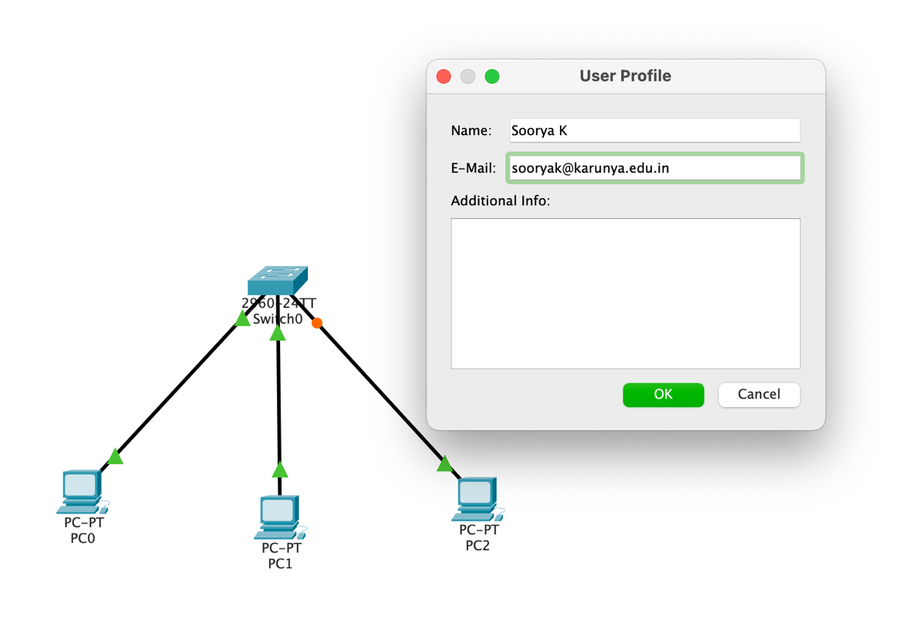

**ADDRESSING TABLE(Router)**

|  |  |  |  |  |
| --- | --- | --- | --- | --- |
| **Device** | **Interface** | **IP Address** | **Subnet Mask** | **Default Gateway** |
| **R1** | **Fa0/0** | **192.168.1.1** | **255.255.255.0** | NA |
| **PC1** | **NIC** | **192.168.1.2** | **255.255.255.0** | 192.168.1.1 |
| **PC2** | **NIC** | **192.168.1.3** | **255.255.255.0** | 192.168.1.1 |
| **PC3** | **NIC** | **192.168.1.4** | **255.255.255.0** | 192.168.1.1 |

**ADDRESSING TABLE (Switch)**

|  |  |  |  |  |
| --- | --- | --- | --- | --- |
| **Device** | **Interface** | **IP Address** | **Subnet Mask** | **Default Gateway** |
| **S1** | **vlan** | **192.168.1.1** | **255.255.255.0** | NA |
| **PC1** | **NIC** | **192.168.1.2** | **255.255.255.0** | 192.168.1.1 |
| **PC2** | **NIC** | **192.168.1.3** | **255.255.255.0** | 192.168.1.1 |
| **PC3** | **NIC** | **192.168.1.4** | **255.255.255.0** | 192.168.1.1 |

**OUTPUT**

TOPOLOGY OF ROUTER

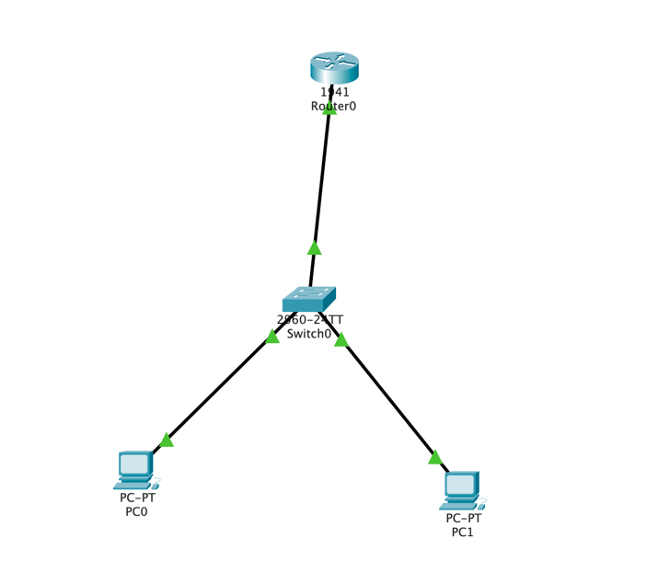

TOPOLOGY OF SWITCH:

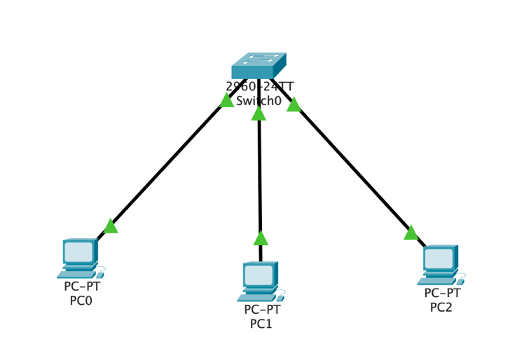

Screenshot of configuring IP address for anyone PC: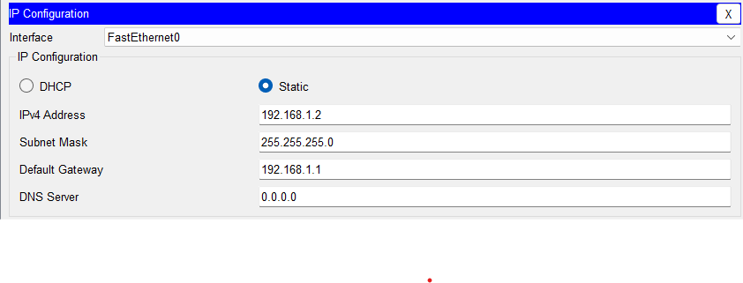Screenshot of Routing Table of any 1 router

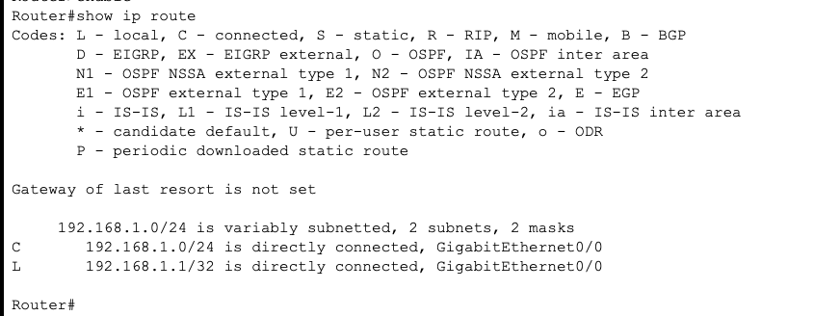

Screenshot of successful ping from PC to PC:

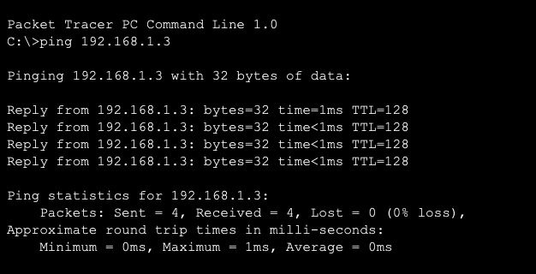

Screenshot of Telnet access.

Screenshot of Mac-Address Table of any one switch

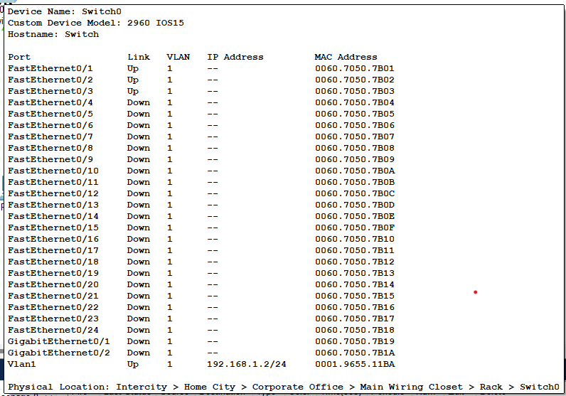

Screenshot of Password validation in console and vty line

Screenshot of all the configuration done(router)

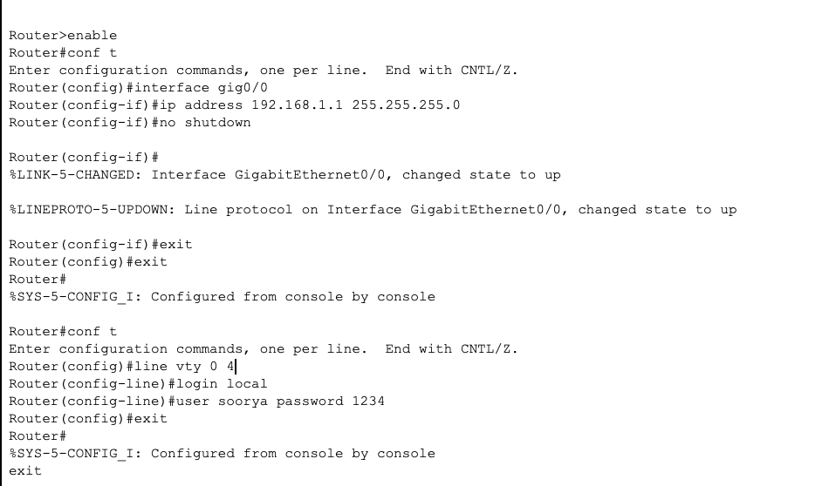

Screenshot of all the configuration done(switch)

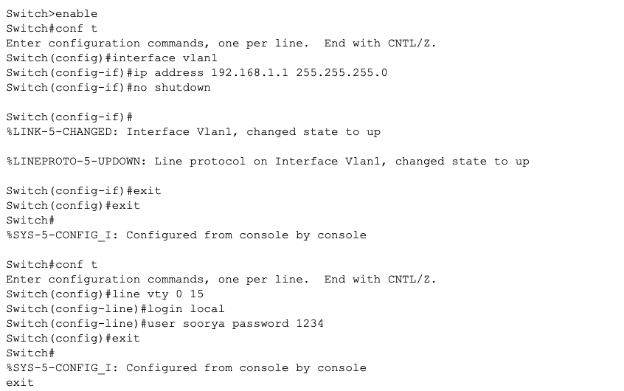

**RESULT**

The required configuration of router and switch was achieved with help of the above mentioned steps and methods.